# Q1

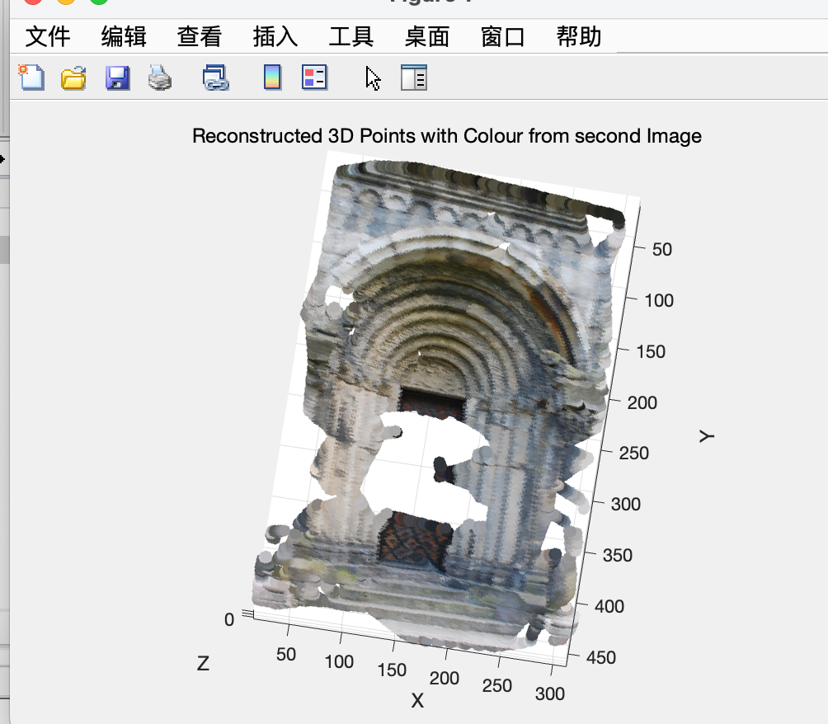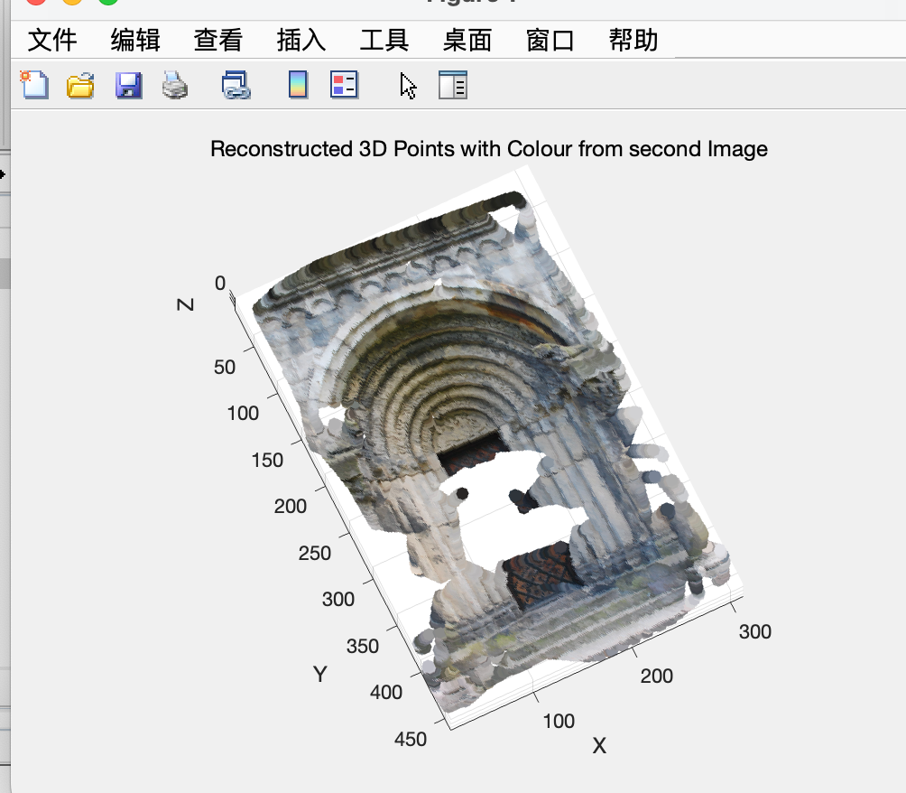

# Q2

The {Densification.m} function's main goal is to use the provided sparse matches to find dense image correspondences.

The following are this function's primary steps:

1. Interpolation of Correspondences: Each pixel point in Image 1 has a corresponding position in Image 2 thanks to interpolation from Image 1 to Image 2 performed with the `griddata` function.

1. Reverse Correspondence Interpolation: In this step, each pixel point in Image 2 has a corresponding position in Image 1 determined by using the `griddata` function to interpolate from Image 2 back to Image 1.

3. Consistency Check for Bidirectional Interpolation: Verify whether the interpolation from Image 1 to Image 2 and the interpolation from Image 2 back to Image 1 are consistent. Dense correspondence is defined as when the distance is less than a threshold (e.g., 2) and they are consistent.

4. Using Reprojection Error to Verify Bidirectional Consistency: Determine the reprojection error for the above-mentioned bidirectional consistency points using the essential matrix E, and then further filter the points according to this error. Retained points are only those that satisfy a specific reprojection error criterion.

Regarding the possible causes of gaps or absent regions in 3D reconstruction:

1. Inadequate Texture Information: Mismatches or match failures may result from smooth or repetitive texture areas.

2. Occlusions: In certain views, certain areas are visible, but they are hidden in others.

3. Limitations of Interpolation: Interpolation, which may not be very accurate, is used to obtain the dense correspondences

4. Big Disparities: Matching can be difficult if objects are at different distances from one another.

5. Changes in Illumination: Matching errors may arise from variations in illumination between the two views.

6. Errors in Camera Parameters: The reconstruction outcomes may be impacted by mistakes in rotation, translation, and intrinsic parameters.

The aforementioned details the operation of the Densification.m function as well as potential causes of holes in 3D reconstruction.

Q3

